Control Award Content Sheet

|  |  |
| --- | --- |
| Team # 7155 | Team Name: The Quantum Potentials |

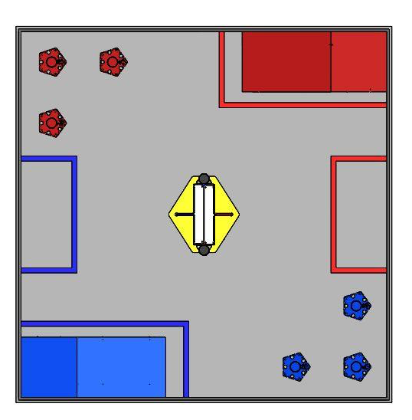

Autonomous:

Driver Controlled:

The Tele-Op code has four separate tasks handling different parts of the robot.

*Hook Task:*

This task deals with toggling the two servo hooks that grab onto the base of the rolling goals in order to move them around. It has a loop that continuously checks if the toggle button (button 2) is pressed. If pressed, the program then checks if the hook is up, using a Boolean statement, and sets the servos to the appropriate position to grab the hook.

*Intake Task:*

This task deals with the two Lego motors that function as the intake for the robot. When the top bumper is pushed, the motors are powered, causing the intake to begin to rake in balls with its zip ties. Any bumper button will stop the intake. When the lift has been raised and the robot is ready to deposit balls, the driver can push the bottom button, which spins the motors slowly in the reverse direction to deposit them into the tubes.

*Main Task:*

The Main task deals with several parts of the robot that do not need a separate task to control toggling. This task is broken up into two methods: Lift and Wheels.

*Lift:*

The Lift method controls the linear slide on the robot and allows the ball intake/holder to be raised and lowered in order to score in the various sized goals, and pick up balls from the playing field floor. The program first sets the encoders on the lift motors so that the motors will not keep spinning after the lift has been brought down. This prevents the lift’s winch mechanism from breaking during a match. Should the driver need to cancel these limits, he/she can simply press the Cancel Lift Limits button (button 10). This will remove all limits on the lift and give full manual operation to the driver. The driver presses the top bumper to raise the lift and the lower bumper to lower the lift.

*Wheels:*

The robot uses a tank drive to control the wheels. The driver uses the left and right knobs to control the left and right wheels respectively. Because the controllers are not always the most accurate, the robot will not take an input unless the controller input is greater than 10. This ensures that the robot does not jitter around on the playing field and helps us ensure that our motors will last longer.

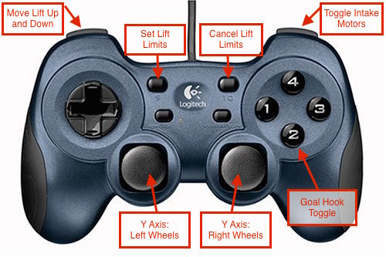

All of our code for this competition can be viewed at <http://github.com/FTC7155/2015>